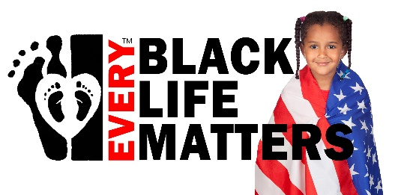

FOR IMMEDIATE RELEASE Contact: Kevin McGary, EBLM
Phone: 510-886-7319
Email: info@EveryBLM.com

Every Black Life Matters Writes an Open Letter to MLB
Where is the same courage as Branch Rickey?
[SAN JOSE, CA, April 12, 2021] This weekend, Co-Founders Kevin McGary and Neil Mammen of Every Black Life Matters(EBLM), a Christian alternative organization to BLM, released an open letter to the MLB questioning their strong history of supporting civil rights after last week’s decision to punish Georgia by withdrawing the All-Star games from the state.
We’d like to take a quote directly from the MLB website:
“On April 15, 1947 he stepped onto Ebbets Field, home of the Dodgers, as their first baseman thus officially ending the color barrier in baseball. It was a moment of great pride for the African-American community. Of the over 26,000 attending the game that day, 14,000 were African-American. Robinson did not disappoint. In his first season, he was named the first ever Rookie of the Year and hit .297, scored 125 runs and stole 29 bases. His play was a large factor in the Dodgers winning that year's National League title.
As Branch Rickey predicted, despite Robinson's stellar play, he endured a great amount of verbal abuse from fans. And the abuse was not restricted to fans. Opposing players hurled verbal insults at Robinson but they also played rough and employed tactics that many saw as outside the bounds of acceptable play. But there were Major Leaguers who accepted and encouraged Robinson. In 1948, Robinson's teammate Pee Wee Reese came to his aid during a game in Cincinnati where the fans were especially ruthless. Reese simply walked over, put his arm around Robinson and looked out at the crowd. This show of solidarity proved that Robinson was accepted by his teammates and should be by those who came and watched the game.”
Ironically, in a few days from now on April 15 it will have been 74 years ago that the MLB began to unravel segregation in sports. Jackie Robinson and Rickey made a small step for man, but a huge step for this country.
Where has that courage gone?
Instead of Major League Baseball (MLB) moving venues and threatening Georgians, they should redouble efforts to expand services in Georgia. The MLB alone was destined to bring over $190,000,000 in commerce during the MLB All-Star festivities; this represents tens of thousands of employment opportunities for Georgians! The Georgia employment segment is made up of majority-minority; blacks are the overwhelming majority of minority employment in Georgia.
The entire letter can be found at https://everyblm.com/open-letter-to-mlb/

Every Black Life Matters is a pro-life, pro-capitalist, pro-nuclear family organization who boldly stands in direct opposition to BLM. Their mission is to protect black life from conception to death by confronting injustice and deconstructing barriers inside and outside the black community through a national platform of training, networked resources, community organizing and faith building.

###

If you would like more information about this topic, please call Kevin McGary at 510-886-7319, or email info@everyBLM.com.

Open Letter to MLB
https://everyblm.com/open-letter-to-mlb/
MLB Website:
https://www.mlb.com/phillies/community/educational-programs/uya-negro-league/road-to-baseball-integration
Facebook Page of EBLM
https://facebook.com/everyblm
Website
https://everyblm.com

